**ITA 0443 - STATISTICS WITH R PROGRAMMING FOR REAL TIME**

**PROBLEM**

**DAY 4– LAB MANUAL**

**Reg No:19212115**

**Name:S.Dhansh kumar**

**LINEAR REGRESSION ANALYSIS IN R**

**Exercise**

1. Using linear regression analysis establish a relationship between height and weight of a

person using the input vector given below.

# Values of height

151, 174, 138, 186, 128, 136, 179, 163, 152, 131

# Values of weight.

W2uy763, 81, 56, 91, 47, 57, 76, 72, 62, 48

Predict the weight of a person with height 170. Visualize the regression graphically.

**Program**

# Input vector for height and weight

height <- c(151, 174, 138, 186, 128, 136, 179, 163, 152, 131)

weight <- c(63, 81, 56, 91, 47, 57, 76, 72, 62, 48)

# Create a linear regression model

model <- lm(weight ~ height)

# Predict the weight of a person with height 170

new_height <- data.frame(height = 170)

new_weight <- predict(model, newdata = new_height)

cat("The predicted weight for a person with height 170 is:", new_weight)

# Visualize the linear regression graphically

plot(height, weight, xlab = "Height", ylab = "Weight", main = "Linear Regression")

abline(model, col = "red")

**output:**

> # Input vector for height and weight

> height <- c(151, 174, 138, 186, 128, 136, 179, 163, 152, 131)

> weight <- c(63, 81, 56, 91, 47, 57, 76, 72, 62, 48)

>

> # Create a linear regression model

> model <- lm(weight ~ height)

>

> # Predict the weight of a person with height 170

> new_height <- data.frame(height = 170)

> new_weight <- predict(model, newdata = new_height)

> cat("The predicted weight for a person with height 170 is:", new_weight)

The predicted weight for a person with height 170 is: 76.22869>

> # Visualize the linear regression graphically

> plot(height, weight, xlab = "Height", ylab = "Weight", main = "Linear Regression")

> abline(model, col = "red")

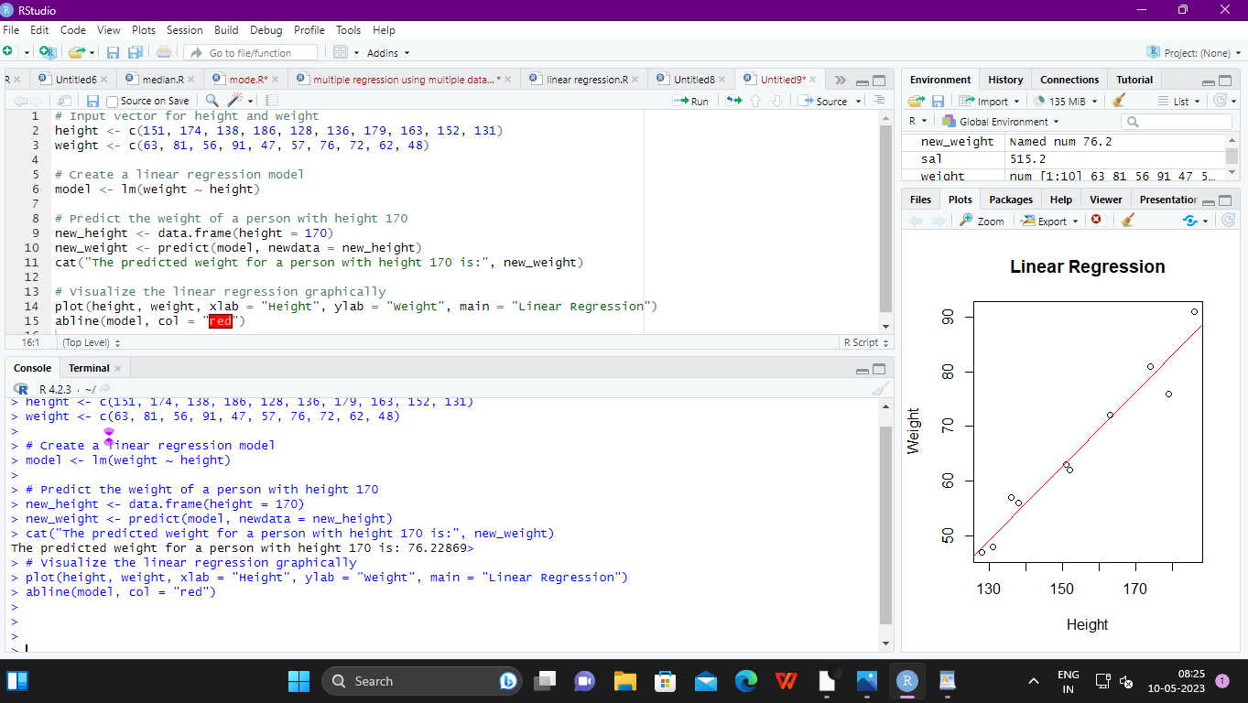

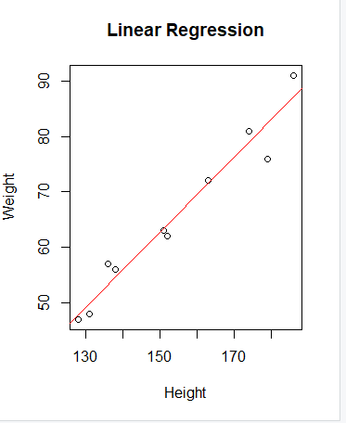ED3

2. Download the Dataset &quot;water&quot; From Rdataset Link.Find out whether there is a linear

relation between attributes&quot;mortality&quot; and&quot;hardness&quot; by plot function.Fit the Data into the

Linear Regression model.Predict the mortality for the hardness=88

**program:**

# Load the HSAUR package

library(HSAUR)

# Load the water dataset

data("water")

# Plot mortality vs hardness

plot(mortality ~ hardness, data = water)

# Fit a linear regression model

model <- lm(mortality ~ hardness, data = water)

# Print the summary of the model

summary(model)

# Create a new data frame with hardness=88

newdata <- data.frame(hardness = 88)

# Predict the mortality using the model

predict(model, newdata)

**output:**

> # Load the water dataset

> data("water")

>

> # Plot mortality vs hardness

> plot(mortality ~ hardness, data = water)

> # Fit a linear regression model

> model <- lm(mortality ~ hardness, data = water)

>

> # Print the summary of the model

> summary(model)

Call:

lm(formula = mortality ~ hardness, data = water)

Residuals:

Min 1Q Median 3Q Max

-348.61 -114.52 -7.09 111.52 336.45

Coefficients:

Estimate Std. Error t value Pr(>|t|)

(Intercept) 1676.3556 29.2981 57.217 < 2e-16 ***

hardness -3.2261 0.4847 -6.656 1.03e-08 ***

---

Signif. codes: 0 ‘***’ 0.001 ‘**’ 0.01 ‘*’ 0.05 ‘.’ 0.1 ‘ ’ 1

Residual standard error: 143 on 59 degrees of freedom

Multiple R-squared: 0.4288, Adjusted R-squared: 0.4191

F-statistic: 44.3 on 1 and 59 DF, p-value: 1.033e-08

> # Create a new data frame with hardness=88

> newdata <- data.frame(hardness = 88)

>

> # Predict the mortality using the model

> predict(model, newdata)

1

1392.46

>

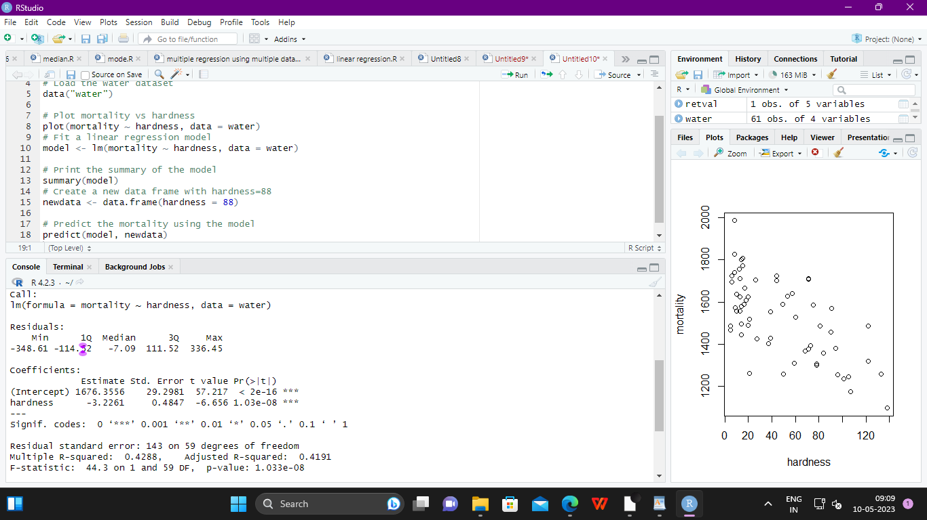

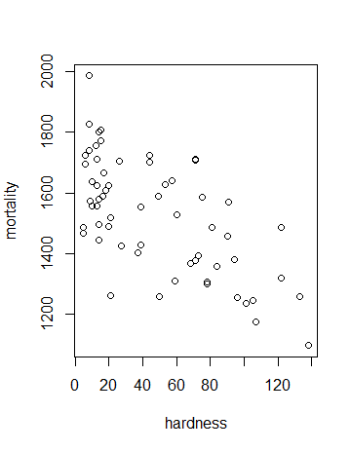

**MULTIPLE REGRESSION ANALYSIS IN R**

**Exercise:**

**3.Generate a multiple regression model using the built in dataset mtcars.It gives a comparison**

**between different car models in terms of mileage per gallon (mpg), cylinder**

**displacement(&quot;disp&quot;), horse power(&quot;hp&quot;), weight of the car(&quot;wt&quot;) and some more parameters.**

**Establish the relationship between &quot;mpg&quot; as a response variable with &quot;disp&quot;,&quot;hp&quot; and &quot;wt&quot; as**

**predictor variables. Predict the mileage of the car with dsp=221,hp=102 and wt=2.91.**

**program**

# Load the mtcars dataset

data(mtcars)

# Create a multiple regression model with mpg as response variable and disp, hp, and wt as predictor variables

model <- lm(mpg ~ disp + hp + wt, data = mtcars)

# Summary of the model

summary(model)

# Predict the mileage of a car with disp=221, hp=102, and wt=2.91

new_data <- data.frame(disp = 221, hp = 102, wt = 2.91)

prediction <- predict(model, newdata = new_data)

cat("The predicted mileage for the given values of disp, hp, and wt is:", prediction)

**OUTPUT:**

> # Load the mtcars dataset

> data(mtcars)

>

> # Create a multiple regression model with mpg as response variable and disp, hp, and wt as predictor variables

> model <- lm(mpg ~ disp + hp + wt, data = mtcars)

>

> # Summary of the model

> summary(model)

Call:

lm(formula = mpg ~ disp + hp + wt, data = mtcars)

Residuals:

Min 1Q Median 3Q Max

-3.891 -1.640 -0.172 1.061 5.861

Coefficients:

Estimate Std. Error t value Pr(>|t|)

(Intercept) 37.105505 2.110815 17.579 < 2e-16 ***

disp -0.000937 0.010350 -0.091 0.92851

hp -0.031157 0.011436 -2.724 0.01097 *

wt -3.800891 1.066191 -3.565 0.00133 **

---

Signif. codes: 0 ‘***’ 0.001 ‘**’ 0.01 ‘*’ 0.05 ‘.’ 0.1 ‘ ’ 1

Residual standard error: 2.639 on 28 degrees of freedom

Multiple R-squared: 0.8268, Adjusted R-squared: 0.8083

F-statistic: 44.57 on 3 and 28 DF, p-value: 8.65e-11

>

> # Predict the mileage of a car with disp=221, hp=102, and wt=2.91

> new_data <- data.frame(disp = 221, hp = 102, wt = 2.91)

> prediction <- predict(model, newdata = new_data)

> cat("The predicted mileage for the given values of disp, hp, and wt is:", prediction)

The predicted mileage for the given values of disp, hp, and wt is: 22.65987>

> RTF54

